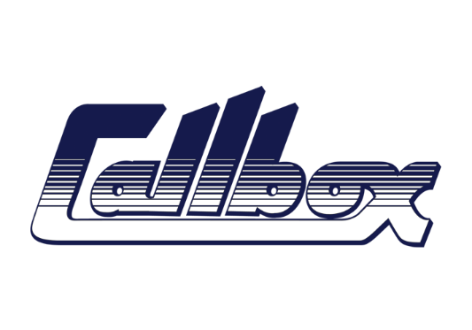

CALLBOX: 01932 502050

JOE WRIGHT: 1st AC M:07966529502 E: JoeWright172@gmail.com

[www.callboxdiary.com](http://www.callboxdiary.com)

**Commercials & Digital Content**

**PRODUCTION COMPANY PRODUCT Director DoP Grade**

Nice Shirt The Glenlivet Stuart Douglas Magni Ágústsson IKS 1st AC

Prodigious Subway James Haworth Jim Jolliffe 1st AC

Pulse Films Wagamama Hector Dockrill Pat Dolan 1st AC Underwater

Smuggler Lloyds Henry Alex Rubin Tom Townend 1st AC Underwater

Pulse Films Sports Direct Freddie Waters Patrick Duroux 1st AC

Smith & Jones TK Maxx Ulf Johannsson Andrzej Sekula 1st AC

Smuggler/LS Prods McDonalds Max Weiland Stéphane Fontaine 1st AC

Sky TV Sky Movies Tom Cruise Tim Postins John Mathieson BSC 1st AC

Cherry Films Land Rover Jake Nava Jaime Feliu Torres/ Jim Jolliffe 1st AC

Another Film Co Sky Sports Steve Reeves Jim Jolliffe 1st AC

O Positive ITV X David Shane Sebastian Blenkov 1st AC

Smuggler Palo Alto Networks Adam Berg Lasse Frank 1st AC

Pulse Films M&S Dom & Nic Stephen Keith-Roach 1st AC

North 6 H&M Xavier Dolan André Turpin 1st AC Underwater

Whisper TV Neom Stuart Douglas Stuart Douglas 1st AC Underwater

Smith & Jones MKB Ulf Johansson Andrzej Sekula 1st AC

Love Box Ltd Love Box in Your Living Room Daniel Kleinman Denis Crossan BSC 1st AC

Moxie Pictures Premier Inn Ben Wheatley Peter Suschitzky 1st AC

Knucklehead Lancome Peter Lindbergh Philippe Le Sourd 1st AC

Rattling Stick Nike Ringan Ledwidge Matthew Libatique ASC 1st AC

Stink H&M Nicolas Winding Refn Philippe Le Sourd 1st AC

Smith & Jones Bundaberg Rum Ulf Johansson Andrzej Sekula 1st AC

Moxie Pictures BT Sport Ben Wheatley Magni Ágústsson IKS 1st AC

Rattling Stick Optus Ivan Bird Ivan Bird 1st AC

Rogue Films TA Finn McGough Jaime Feliu Torres 1st AC

FILMS & TV

ATB FAE Ltd Above The Below Idris Elba James Friend BSC/ASC 1st AC Underwater

SDTA Productions Blitz Steve McQueen Yorick Le Saux 1st AC Underwater

GSR UK Productions Lord Of The Rings “Power Of The Ring” Vic Armstrong Peter Field 1st AC Underwater

Netflix Locked In Nour Wazzi Remi Adeferasin BSC 1st AC Underwater

Apple TV Silo Season 2 Aric Avelino / Michael Dinner Ollie Downey / Baz Irvine BSC 1st AC Underwater

Amnesia Productions The Tourist S2 Fergus O’Brien Mark Silk 1st AC Underwater

Warner Bros Wonder Woman 1984(Additonal Photography) Patty Jenkins Matthew Jensen 1st AC B Cam

ABC Career Opportunities ( Malta Unit ) David Petrarca Magni Ágústsson IKS 1st AC A Cam

Entertainment Studios 47 Metres Down Uncaged Johannes Roberts Mark Silk 1st AC B Cam

Rolling Stones Havana Moon Paul Dugdale Brett Turnbull 1st AC

LeftBank Pictures Wallander “Before The Frost” Charles Martin Magni Ágústsson IKS 1st AC A Cam

Hatrick Productions Spy Series 1 Ben Taylor Magni Ágústsson IKS 1st AC

Marvel Entertainment Thor The Dark World Alan Taylor Kramer Morgenthau ASC 1st AC

Columbia Pictures Da Vinci Code (2nd Unit) Todd Hallowell Fraser Taggart 2nd AC

Revolver Pictures Revolver Guy Ritchie Tim Maurice Jones 2nd AC

Eon Productions Tomorrow Never Dies 007 Roger Spottiswoode Robert Elswit ASC 2nd AC